Big Data
(6CS030)

Workshop 2
Subject: Global Air Quality Index (AQI) Analysis & Forecasting

Student ID :2431171
Student Name : Grishma Lamsal
Section: : L6CG24
Tutor : Ms. Rakhee Pandey
Lecturer : Mr. Sandesh Lamsal

Table Of Contents
1. Introduction 1
2.Data Source Identification & Automated Acquisition 1
2.1 Dataset Overview 1
2.2 Why This Dataset? 1
2.3 Data Acquisition and Automation Strategy 2
3.Data Exploration, Transformation and Model Development 2
3.1 Data Understanding 2
3.2 Tools and Libraries 2
3.3 Initial Data Inspection 3
3.4 Exploratory Data Analysis (EDA) 3
3.4.1 Exploratory Visualizations and Analysis 3
3.5 Key Findings from Exploratory Data Analysis 12
3.6 Data Transformation 13
3.7 Model Training 13
3.8 Model Evaluation and Interpretation 14
4. Insights 17
5. Deployment of the Proposed System 18
6. Conclusion 19

Table Of Figures
Figure 1 AQI Category Distribution 1
Figure 2 Top 15 Most Polluted Countries 2
Figure 3 Pollutant Correlation Heatmap 3
Figure 4 AQI Boxplot by Category 4
Figure 5 Average AQI Contribution by Pollutant 5
Figure 6 PM2.5 vs Overall AQI by City 6
Figure 7 Distribution of AQI Value (Histogram + KDE) 7
Figure 8 Pollutant Distribution Comparison (Subplots) 8
Figure 9 Boxplots for All Pollutants (Side by Side) 9
Figure 10 Pairplot (Pollutants vs AQI) 10
Figure 11 AQI Value by Continent / Region (Top 10 Countries Heatmap) 11
Figure 12 Actual vs Predicted AQI 14
Figure 13 Feature Importance 15
Figure 14 Residual Analysis 15

1. Introduction
Air Quality Index (AQI) is a standardized measure used to assess and communicate the level of air pollution and its potential impact on human health. It aggregates the concentration of key pollutants such as Carbon Monoxide (CO), Ozone, Nitrogen Dioxide (NO2), and Particulate Matter (PM2.5) into a single value, categorized into levels ranging from good to hazardous. Monitoring AQI is essential because poor air quality is directly linked to serious health issues, including respiratory diseases, cardiovascular problems, and reduced life expectancy. This project focuses on analyzing a global AQI dataset to understand pollution patterns across countries and cities, identify the key pollutants driving air quality degradation, and apply data analysis and machine learning techniques to generate meaningful insights and predictive capabilities.

2.Data Source Identification & Automated Acquisition

2.1 Dataset Overview
The dataset used in this analysis is the Global Air Pollution Dataset obtained from Kaggle, contributed by Hasibalmuzdadid (https://www.kaggle.com/datasets/hasibalmuzdadid/global-air-pollution-dataset?resource=download) . It contains air quality measurements for thousands of cities across multiple countries, providing a comprehensive view of global pollution levels. The dataset includes key attributes such as City, Country, overall AQI Value, AQI Category, and pollutant-specific sub-indices including CO AQI Value, Ozone AQI Value, NO2 AQI Value, and PM2.5 AQI Value. It is a structured dataset in CSV format and represents a cross-sectional snapshot of air quality, meaning it does not include a time dimension. Despite minor missing values in location fields, all pollutant-related numerical columns are complete, making the dataset suitable for analysis and modeling without significant preprocessing.
Attribute | Details
Dataset Name | Global Air Pollution Dataset
Source | Kaggle : hasibalmuzdadid
Format | CSV (.csv)
Key Columns | Country, City, AQI Value, AQI Category, CO AQI, Ozone AQI, NO2 AQI, PM2.5 AQI (and their categories)
Coverage | Global multiple countries and cities
Type | Cross-sectional snapshot (no timestamp)

2.2 Why This Dataset?
This dataset was selected due to its global coverage and inclusion of major pollutants that are widely recognized as primary indicators of air quality by environmental agencies. It enables comparative analysis across regions and supports the identification of key factors influencing pollution. Additionally, the dataset size is sufficient for exploratory data analysis and machine learning tasks, while remaining manageable for processing in a single-machine environment. Its clean structure and completeness of pollutant data further enhance its suitability for building a reliable and reproducible analytical workflow.

2.3 Data Acquisition and Automation Strategy
In the current implementation, the dataset is manually uploaded and processed within a Google Colab environment, which ensures consistency and ease of use for analysis. However, for a scalable and production-level big data pipeline, automated data acquisition is essential. This can be achieved using the Kaggle API to programmatically download the dataset and schedule periodic updates using tools such as cron jobs or task schedulers. The automated data acquisition process ensures that the system can continuously update with new air quality data, enabling more accurate and timely analysis. By integrating APIs such as OpenAQ, the system can transition from static batch processing to a dynamic data pipeline capable of supporting real-time monitoring and prediction. This significantly enhances the practical applicability of the model in real-world environmental decision-making scenarios.

3.Data Exploration, Transformation and Model Development
A few visualizations were produced to explore the dataset before model training. Each chart is presented below with its corresponding analytical insight.

3.1 Data Understanding
The dataset was first examined to understand its structure, data types, and completeness. The columns representing Country and City are categorical in nature, while AQI Value and all pollutant sub-indices are numerical variables stored as integer types. An analysis of missing values revealed that only a small number of entries were missing in the Country and City fields, while all pollutant-related columns were complete. Since the modeling process relies solely on pollutant values, no rows needed to be removed, allowing the full dataset to be retained for analysis.

3.2 Tools and Libraries
The analysis was conducted using a combination of Python libraries suited for data processing, visualization, and machine learning. The pandas library was used for data loading, inspection, handling missing values, and performing aggregations. NumPy supported numerical operations and metric calculations. Matplotlib and Seaborn were used extensively for data visualization, including histograms, boxplots, correlation heatmaps, and pairplots. Plotly Express was utilized for interactive visualizations, particularly for exploring relationships between PM2.5 and AQI. For model development, the scikit-learn library was used to perform train-test splitting, implement the Random Forest Regressor, and evaluate model performance using metrics such as Mean Absolute Error (MAE), Root Mean Squared Error (RMSE), and R² score.

3.3 Initial Data Inspection
The dataset was first examined to understand its structure and data quality. All five numerical columns, including AQI Value and pollutant sub-indices, were stored as integer types and contained no missing values. Although 427 entries were missing country information and one entry lacked a city name, these did not affect the analysis since the modeling process relied only on pollutant values.
The distribution of AQI categories showed that the majority of cities fall into the Good and Moderate categories, accounting for over 80% of the dataset. However, a smaller but significant proportion of cities fall into Unhealthy and more severe categories, indicating the presence of critical pollution levels in certain regions. This initial inspection suggests that while most cities experience acceptable air quality, there exists a non-negligible subset facing serious environmental and health risks.

3.4 Exploratory Data Analysis (EDA)
Exploratory analysis was conducted to identify patterns, relationships, and distributions within the dataset. The distribution of AQI categories showed that most cities fall within the Good and Moderate ranges, but a smaller proportion of cities experience significantly higher pollution levels, indicating a skewed distribution. Country-level analysis revealed that certain regions consistently exhibit higher average AQI values, suggesting the influence of structural factors such as industrialization and urban density.

3.4.1 Exploratory Visualizations and Analysis
The following visualizations cover three analytical layers aggregate distribution (Charts 1–2), pollutant relationships (Charts 3, 5, 6), category validation (Chart 4), and extended univariate and bivariate EDA (Charts 7–11). Each chart is interpreted analytically with reference to actual dataset values rather than general observations. The sequence is intentional: aggregate patterns are established first, then drilled into by pollutant, then validated statistically before model training begins.

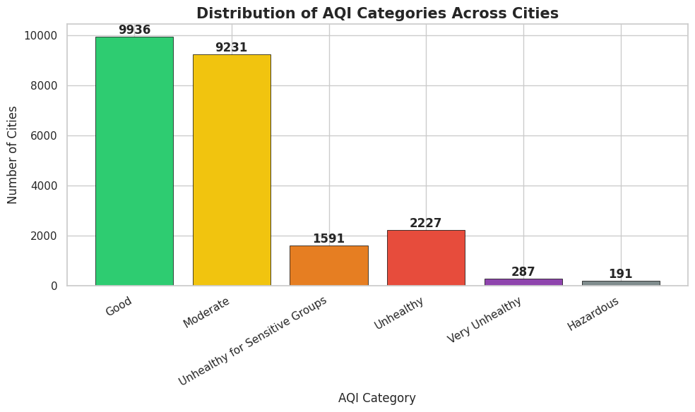
Figure 1 AQI Category Distribution

The bar chart showing the distribution of AQI categories across cities highlights a highly uneven and positively skewed pattern in global air quality. A large majority of cities fall within the lower-risk categories, with 9,936 cities classified as Good and 9,231 as Moderate, together accounting for more than 80% of the dataset. At first glance, this suggests that most cities experience acceptable air quality levels. However, a deeper analysis reveals that a significant number of cities still fall into higher-risk categories, including 1,591 cities in Unhealthy for Sensitive Groups, 2,227 in Unhealthy, 287 in Very Unhealthy, and 191 in Hazardous. Although these categories represent a smaller proportion, they are critically important because they indicate environments where pollution levels can cause serious health impacts, especially for vulnerable populations. The distribution demonstrates that global air quality is not uniformly safe but instead characterized by a concentration of relatively clean cities alongside a smaller but highly significant group of severely polluted ones. This pattern implies that average-based interpretations of air quality can be misleading, as they fail to capture the severity of conditions in the worst-affected areas. From an analytical and policy perspective, the chart suggests that efforts should be focused on reducing pollution in cities within the Unhealthy to Hazardous categories, as targeted interventions in these regions would have the greatest impact on improving public health outcomes.

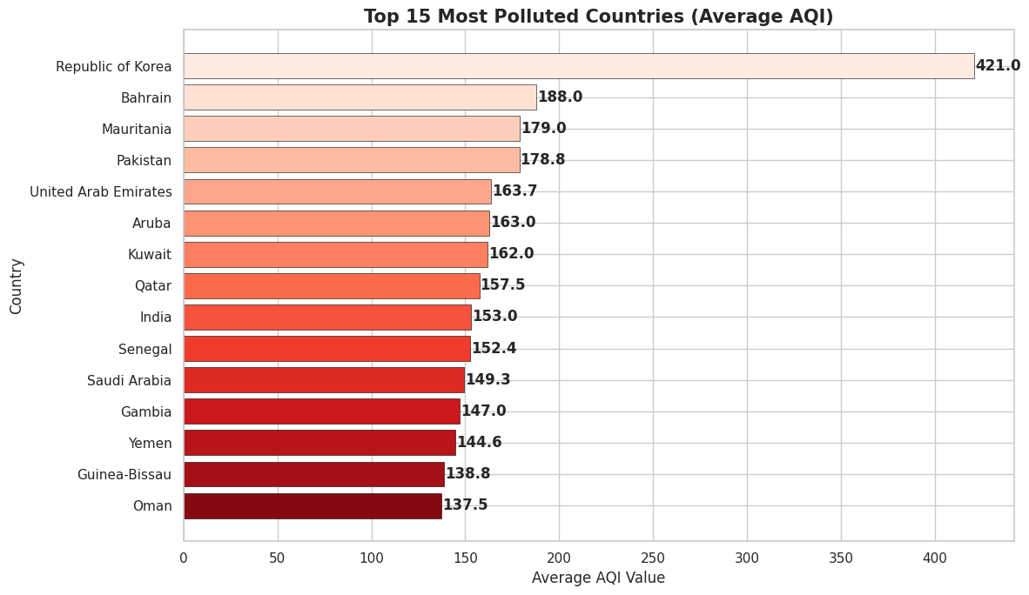
Figure 2 Top 15 Most Polluted Countries

The horizontal bar chart of the top 15 most polluted countries by average AQI highlights clear disparities in national air quality, with the Republic of Korea standing out as a significant outlier at an extremely high AQI of 421, indicating severe and potentially hazardous pollution conditions. Other countries such as Bahrain, Mauritania, Pakistan, India, and the United Arab Emirates fall within the unhealthy range, showing consistently elevated pollution levels rather than occasional spikes. This pattern suggests that air pollution in these regions is driven by structural factors, including rapid urbanization, high population density, industrial emissions, and heavy reliance on fossil fuels. Additionally, in several Middle Eastern and African countries, natural factors such as dust storms further intensify particulate pollution levels. Overall, the chart indicates that air quality issues in these countries are persistent and systemic, requiring targeted and region-specific interventions such as stricter emission regulations, cleaner energy adoption, and improved urban and industrial planning.

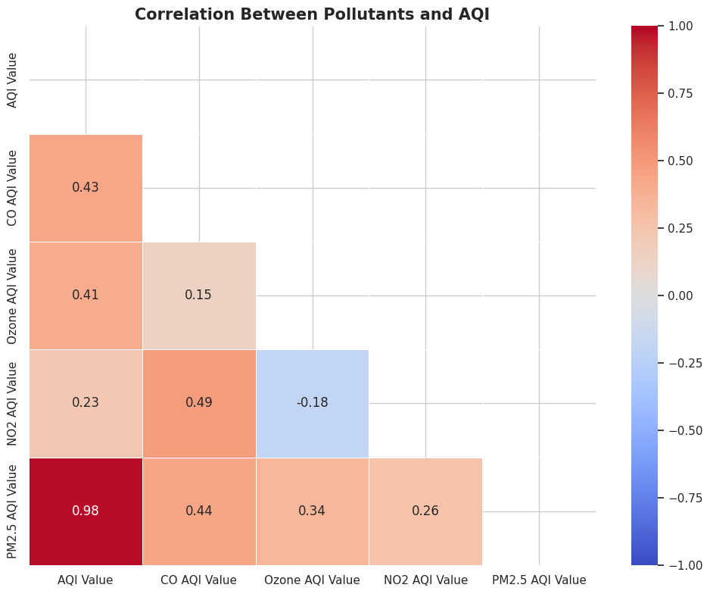
Figure 3 Pollutant Correlation Heatmap
The correlation heatmap illustrates the strength and direction of relationships between individual pollutants and the overall AQI value, providing insight into which pollutants most significantly influence air quality. The most notable observation is the extremely strong positive correlation between PM2.5 and AQI (0.98), indicating that increases in PM2.5 levels almost directly correspond to increases in overall AQI. This confirms that PM2.5 is the dominant driver of air pollution in the dataset. In contrast, CO (0.43) and Ozone (0.41) show moderate positive correlations with AQI, suggesting they contribute to air quality but are not primary determinants. NO2 exhibits a weaker correlation (0.23), indicating a relatively smaller impact on overall AQI levels. Additionally, the relationships among pollutants themselves are relatively low or even negative in some cases, such as the slight negative correlation between NO2 and Ozone (-0.18), implying that these pollutants may originate from different sources or environmental conditions. Overall, the heatmap suggests that air quality is not influenced equally by all pollutants, and that effective pollution control strategies should prioritize reducing PM2.5 emissions, as it has the most significant and direct impact on AQI levels.
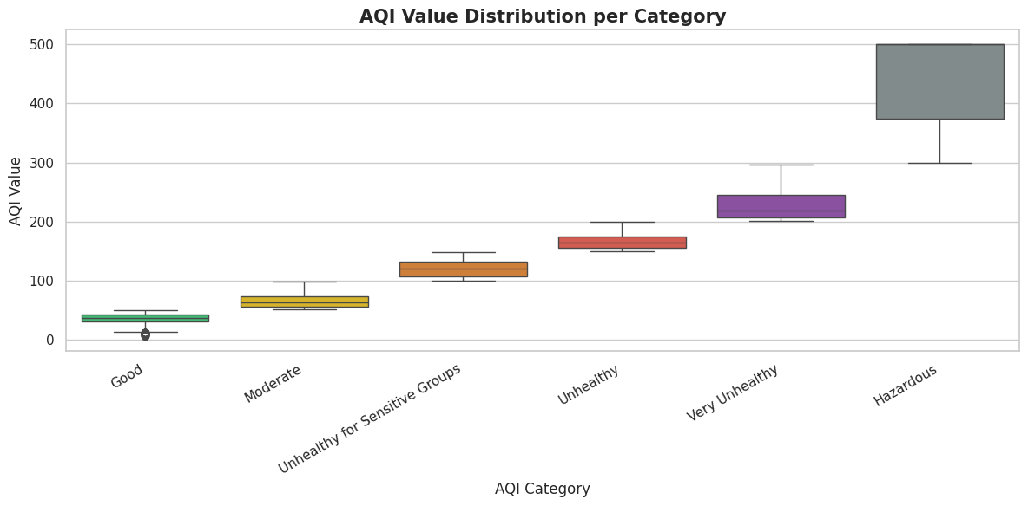
Figure 4 AQI Boxplot by Category
The boxplot of AQI value distribution across categories illustrates how AQI values are spread within each classification level and confirms the consistency of category boundaries. Each category shows a clear upward shift in median AQI values from Good to Hazardous, indicating that the classification system is properly aligned with increasing pollution severity. The Good and Moderate categories have relatively narrow interquartile ranges, suggesting that most cities within these groups experience stable and less variable air quality conditions. As the categories progress toward Unhealthy and Very Unhealthy, the spread of values becomes wider, indicating greater variability and less predictability in pollution levels. The Hazardous category shows the largest spread, with AQI values ranging widely and reaching the maximum levels, reflecting extreme and unstable pollution conditions. This increasing variability implies that higher pollution categories are influenced by more complex and fluctuating environmental factors, such as sudden emission spikes or weather conditions. Overall, the plot confirms that AQI categories are well-defined but also highlights that risk and uncertainty increase significantly at higher pollution levels, reinforcing the need for stricter monitoring and control measures in these ranges.

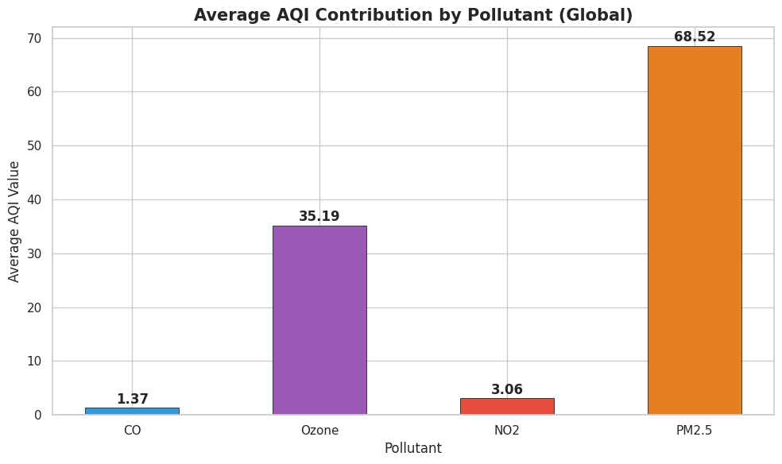
Figure 5 Average AQI Contribution by Pollutant
The bar chart showing the average AQI contribution by pollutants clearly demonstrates that PM2.5 is the dominant factor influencing overall air quality on a global scale. With an average value of 68.52, PM2.5 contributes nearly twice as much as Ozone (35.19) and significantly more than CO (1.37) and NO2 (3.06), which have minimal contributions in comparison. This large disparity indicates that fine particulate matter is the primary driver of air pollution levels across most cities, largely due to its widespread sources such as vehicle emissions, industrial combustion, construction activities, and biomass burning. In contrast, the relatively low average values of CO and NO2 suggest that these pollutants either occur at lower concentrations or have less variability in the dataset, limiting their overall impact on AQI. Ozone shows a moderate contribution, indicating it plays a secondary but still relevant role, particularly in regions affected by photochemical reactions. Overall, the chart implies that efforts to improve air quality should prioritize reducing PM2.5 emissions, as targeting this pollutant would have the most significant and immediate effect

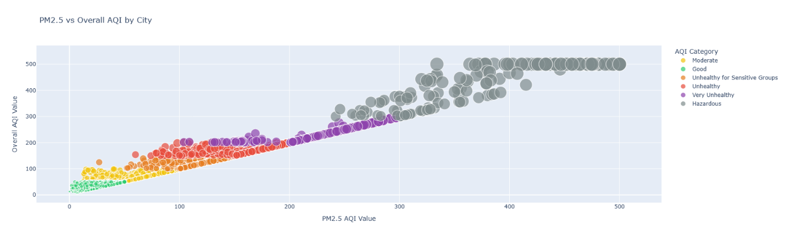
Figure 6 PM2.5 vs Overall AQI by City
The scatter plot of PM2.5 versus overall AQI across cities reveals a very strong and nearly linear relationship between the two variables, indicating that PM2.5 is the primary determinant of overall air quality. As PM2.5 values increase along the x-axis, AQI values on the y-axis rise almost proportionally, forming a tight diagonal pattern with minimal dispersion. The color-coded AQI categories further reinforce this relationship, as lower PM2.5 levels correspond to Good and Moderate categories, while higher values align with Unhealthy, Very Unhealthy, and Hazardous levels. This clear progression shows that changes in PM2.5 alone are sufficient to drive transitions between AQI categories. The clustering of points along a straight line also suggests that AQI is largely computed based on PM2.5 values in most cases, rather than being influenced equally by all pollutants. From an analytical perspective, this implies that predictive models achieving high accuracy are primarily capturing this direct relationship rather than uncovering complex interactions. In practical terms, the plot highlights that controlling PM2.5 emissions would have the most immediate and significant impact on improving air quality, as reductions in this single pollutant would directly translate into lower AQI levels across cities.

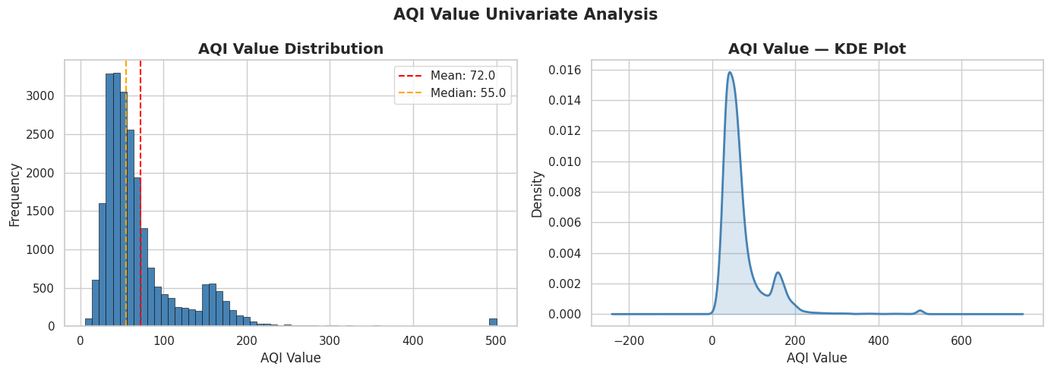
Figure 7 Distribution of AQI Value (Histogram + KDE)
The univariate analysis of AQI values, shown through the histogram and KDE plot, reveals a strongly right-skewed distribution of air quality across cities. The histogram indicates that most AQI values are concentrated in the lower range, particularly between 30 and 80, which corresponds to Good and Moderate air quality levels. This is further supported by the median value of 55, which lies below the mean value of 72, confirming the presence of positive skewness. The gap between the mean and median suggests that a smaller number of cities with very high AQI values are pulling the average upward. The KDE plot reinforces this observation by showing a sharp peak at lower AQI values and a long tail extending toward higher values, even reaching extreme levels near 500. This long tail represents cities experiencing severe to hazardous pollution conditions. The presence of this skewed distribution implies that while most cities have relatively acceptable air quality, there exists a significant minority facing extreme pollution. From an analytical perspective, this means that average AQI alone is not a reliable indicator of overall air quality, as it underrepresents high-risk areas. Therefore, policy and analysis should focus not only on central tendencies but also on the tail of the distribution, where the most critical environmental and health risks are concentrated.

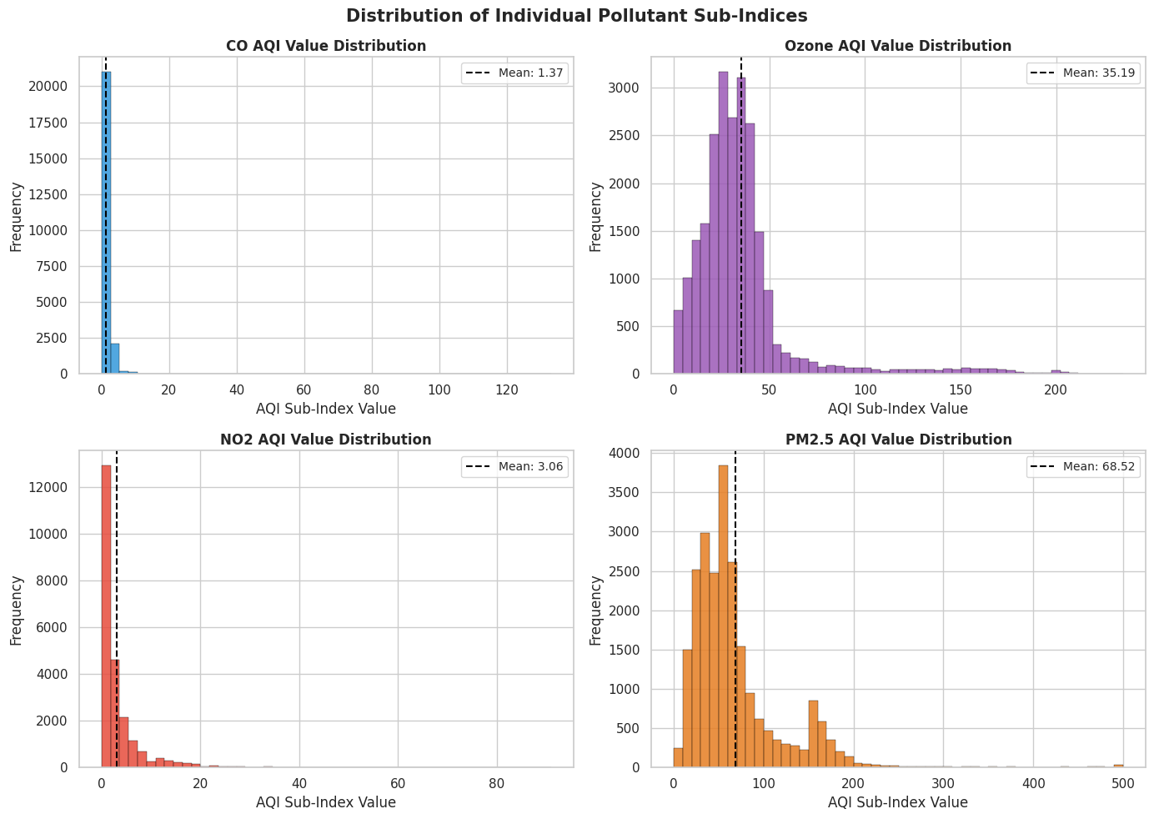
The distribution plots of individual pollutant sub-indices reveal significant differences in how each pollutant contributes to overall air quality, particularly in terms of variability and spread. CO and NO2 show extremely concentrated distributions, with most values clustered very close to zero and minimal spread, indicating that these pollutants remain consistently low across the majority of cities and contribute little variation to AQI. Their distributions are highly skewed with occasional outliers, suggesting that while spikes do occur, they are rare and not the primary drivers of pollution levels. In contrast, Ozone displays a broader and more balanced distribution, with values spread across a wider range and a moderate mean, indicating a more consistent but secondary influence on AQI. The most striking pattern is observed in PM2.5, which exhibits the widest distribution and highest variability, with values spanning from low to extremely high levels, including a long tail reaching hazardous ranges. This indicates that PM2.5 is not only present in most cities but also varies significantly in intensity, making it the dominant contributor to differences in air quality. Overall, these distributions imply that while multiple pollutants are measured, only PM2.5 provides substantial variability and explanatory power for AQI, reinforcing the need to prioritize its control in pollution management strategies.
Figure 8 Pollutant Distribution Comparison (Subplots)

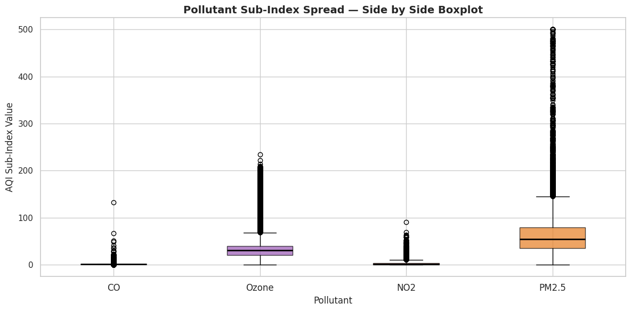
Figure 9 Boxplots for All Pollutants (Side by Side)

The side-by-side boxplot of pollutant sub-index values highlights the stark differences in variability and distribution across the four pollutants, clearly identifying which ones drive air quality changes. CO and NO2 exhibit extremely narrow boxes with medians close to zero, indicating that their values are consistently low across most cities, with limited variation. Although both show several outliers, these are relatively sparse and do not significantly influence the overall distribution, suggesting that these pollutants contribute minimally to AQI variability. Ozone displays a wider interquartile range and a higher median compared to CO and NO2, indicating a more noticeable but still moderate contribution to air quality, with some variability across regions. In contrast, PM2.5 stands out with the largest spread, highest median, and a substantial number of extreme outliers extending to very high values. This wide dispersion indicates that PM2.5 levels vary significantly between cities and frequently reach severe levels, making it the most influential pollutant in determining AQI. Overall, the boxplot reinforces the conclusion that while multiple pollutants are present, PM2.5 is the primary source of variation and risk in air quality, and therefore should be the main focus of pollution control strategies.

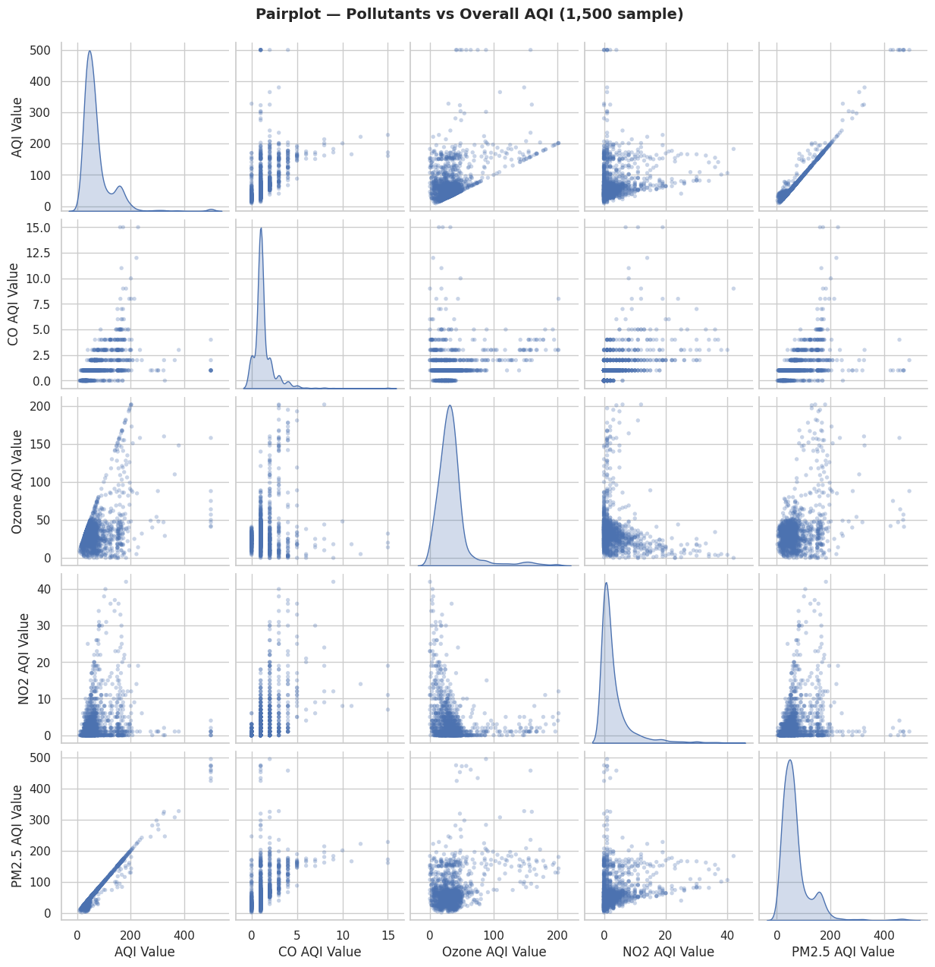
Figure 10 Pairplot (Pollutants vs AQI)
The pairplot comparing all pollutants with overall AQI provides a comprehensive view of both individual distributions and inter-variable relationships, clearly highlighting which pollutants have meaningful influence on air quality. The diagonal plots show the distributions of each variable, where AQI and PM2.5 display wider spreads and noticeable skewness, while CO and NO2 are highly concentrated near lower values, indicating limited variability. The most significant observation appears in the scatter plots between PM2.5 and AQI, where a strong, almost perfectly linear relationship is visible, confirming that PM2.5 is the primary determinant of overall AQI. In contrast, scatter plots involving CO and NO2 show dense vertical clustering with little clear pattern, suggesting weak or negligible relationships with AQI. Ozone shows a slightly more dispersed relationship, indicating a moderate but less consistent influence. Additionally, the lack of strong relationships among the pollutants themselves suggests that they may originate from different sources or environmental processes. Overall, the pair plot reinforces earlier findings that PM2.5 is the only pollutant with strong predictive power for AQI, while the others contribute marginally, supporting the conclusion that air quality management efforts should prioritize controlling PM2.5 emissions.

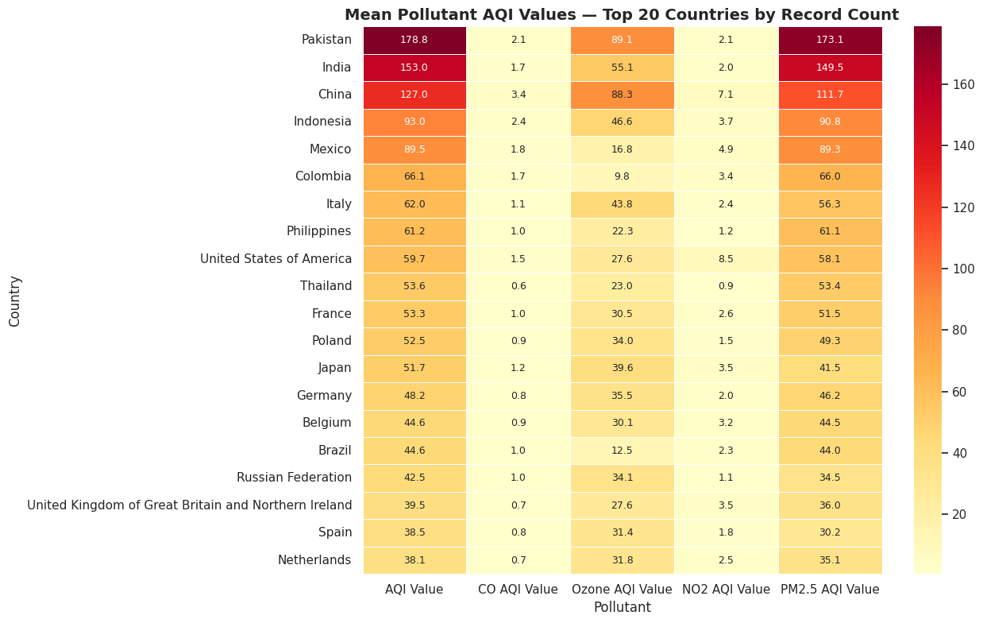
Figure 11 AQI Value by Continent / Region (Top 10 Countries Heatmap)
The heatmap shows that countries with the highest AQI values, such as Pakistan, India, and China, also have significantly high PM2.5 levels, indicating that air pollution in these regions is mainly driven by combustion sources like vehicles, industry, and biomass burning. This suggests that pollution is structural and requires long-term actions such as stricter emission controls and cleaner energy adoption. In contrast, developed countries such as Germany, the United Kingdom, and the Netherlands have lower AQI and PM2.5 levels but relatively higher ozone values, implying that pollution there is more influenced by atmospheric chemical reactions. The consistently low CO and NO2 values across countries indicate limited contribution to overall AQI variation. Overall, the heatmap highlights that air pollution patterns vary by region, and effective solutions must be tailored, with a strong focus on reducing PM2.5 in highly polluted countries

3.5 Key Findings from Exploratory Data Analysis
The exploratory data analysis reveals several significant patterns in global air quality, along with their underlying causes and implications. Firstly, the AQI distribution is strongly right skewed, where most cities fall within acceptable air quality ranges, while a smaller proportion experience extremely high pollution levels. This skewness occurs because pollution is not evenly distributed but concentrated in specific high-risk regions, typically characterized by dense populations and industrial activity. The implication is that global averages provide a misleading sense of safety, as they fail to reflect the severity of pollution in the most affected areas. This suggests that policy efforts should prioritize high-pollution regions rather than relying on overall global improvements.
A key analytical finding is the dominance of PM2.5 as the primary driver of AQI. This occurs because PM2.5 originates from major pollution sources such as vehicle emissions, industrial combustion, construction activities, and biomass burning, all of which are prevalent in urban and developing regions. The strong linear relationship between PM2.5 and AQI implies that air quality degradation is largely determined by particulate pollution rather than a balanced contribution from all pollutants. This means that reducing PM2.5 emissions would result in the most significant improvement in air quality. Therefore, targeted actions such as stricter emission standards, improved fuel quality, and control of construction dust are likely to have the highest impact.
In contrast, pollutants such as CO and NO2 exhibit low variability and weak relationships with AQI in this dataset. This suggests that either their concentrations are relatively stable across cities or that they are less dominant in determining overall air quality compared to PM2.5. The implication is that including these pollutants in predictive models contributes limited additional value. However, this does not mean they are unimportant in real-world scenarios, but rather that their impact is context-dependent and may become more significant in specific regions or under different environmental conditions.
Country-level analysis further shows that air pollution is structurally driven rather than randomly distributed. Countries with consistently high AQI values are typically associated with rapid urbanization, industrial concentration, weak environmental regulation, and high energy demand. In some regions, natural factors such as dust storms also contribute to elevated pollution levels. This indicates that air pollution is deeply linked to economic and developmental patterns. The implication is that short-term fixes are insufficient, and long-term structural changes are required. Effective actions include enforcing emission regulations, transitioning to renewable energy, improving urban planning, and reducing reliance on high-pollution industrial processes.
Additionally, regional differences in pollutant profiles highlight that air pollution is not a uniform problem. Some regions are dominated by particulate pollution, while others show relatively higher levels of secondary pollutants such as ozone. This variation implies that a one-size-fits-all approach to air quality management would be ineffective. Instead, region-specific strategies must be implemented, focusing on the dominant pollution sources in each area.
Another critical observation is the presence of extreme AQI values, particularly those reaching hazardous levels. These are not statistical anomalies but represent real-world pollution events caused by factors such as smog accumulation, seasonal burning, or industrial emissions. The implication is that these extreme conditions pose serious public health risks and require immediate intervention. This supports the need for real-time monitoring systems and emergency response mechanisms to mitigate short-term pollution spikes.
Finally, from a modeling perspective, the strong relationship between PM2.5 and AQI explains the high predictive performance observed in later stages. Since AQI is derived from pollutant sub-indices, the model is effectively learning a deterministic relationship rather than uncovering new patterns. This implies that while the model performs well, its practical usefulness is limited unless extended to predict future pollutant levels. Therefore, future improvements should focus on incorporating time-series data and real-time inputs to enhance predictive capability.
Overall, the exploratory data analysis demonstrates that global air quality is driven by a combination of dominant pollutants, regional factors, and structural conditions. These findings not only guide model development but also provide meaningful insights for environmental policy and decision-making.

3.6 Data Transformation
Before model development, the dataset was prepared to ensure it was suitable for machine learning analysis. Since all pollutant-related numerical columns contained no missing values, no rows were removed, allowing the full dataset of 23,463 records to be retained. This ensures that important extreme values, particularly those representing hazardous pollution conditions, are preserved in the analysis rather than being treated as noise.
The AQI Category variable was encoded into numerical form to maintain consistency in data representation, although it was not used directly as a target variable in the regression model. The feature matrix (X) was constructed using the four pollutant sub-indices: CO, Ozone, NO2, and PM2.5 AQI values. The target variable (y) was defined as the overall AQI Value.
The dataset was then split into training and testing sets using an 80–20 ratio, resulting in 18,770 training samples and 4,693 testing samples. A fixed random state was used to ensure reproducibility of results. This step ensures that the model is evaluated on unseen data, providing a reliable measure of its generalization performance.

3.7 Model Training
A Random Forest Regressor was selected to model the relationship between pollutant levels and overall AQI. This choice was informed by insights obtained during exploratory data analysis, which revealed non-linear relationships, skewed distributions, and the presence of outliers in the dataset.
Random Forest is particularly suitable in this context for several reasons. Firstly, it is capable of handling non-linear interactions between variables, which is important given the complex environmental processes influencing air quality. Secondly, it is robust to outliers and does not require strict assumptions about data distribution, making it well-suited for the skewed nature of AQI data. Thirdly, as an ensemble method combining multiple decision trees, it reduces variance and improves prediction stability compared to a single model.
The model was trained using 150 decision trees, allowing it to capture patterns across different subsets of the data. During training, the model learns how variations in pollutant levels contribute to changes in AQI, effectively approximating the relationship between input features and the target variable.

3.8 Model Evaluation and Interpretation
The performance of the model was evaluated using standard regression metrics. The Mean Absolute Error (MAE) was 0.2299, indicating that the average prediction error is very small. The Root Mean Squared Error (RMSE) was 2.6541, showing that larger errors are also limited. The R² score of 0.9978 indicates that the model explains nearly all the variance in AQI values.
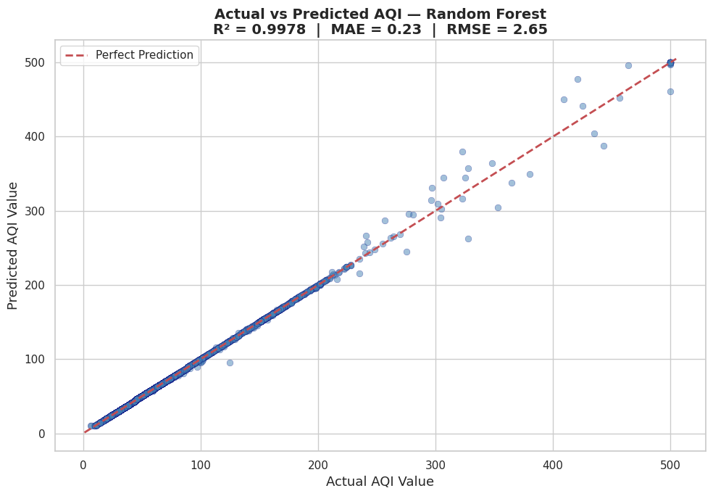
Figure 12 Actual vs Predicted AQI
The predicted values closely align with the actual AQI values, as observed in the actual versus predicted scatter plot, where points lie near the diagonal line representing perfect predictions. This suggests that the model performs consistently across the entire AQI range, although slight deviations are observed at higher AQI values due to the presence of extreme cases.
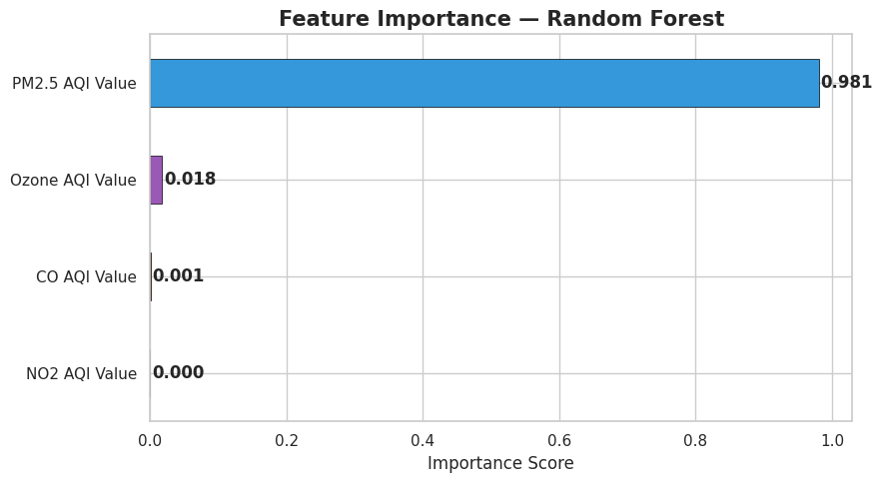
Figure 13 Feature Importance
Feature importance analysis further reinforces the findings from exploratory data analysis. PM2.5 was assigned an importance score of 0.981, while Ozone, CO, and NO2 contributed minimally. This confirms that the model is primarily driven by PM2.5, validating earlier observations that it is the dominant pollutant influencing air quality.
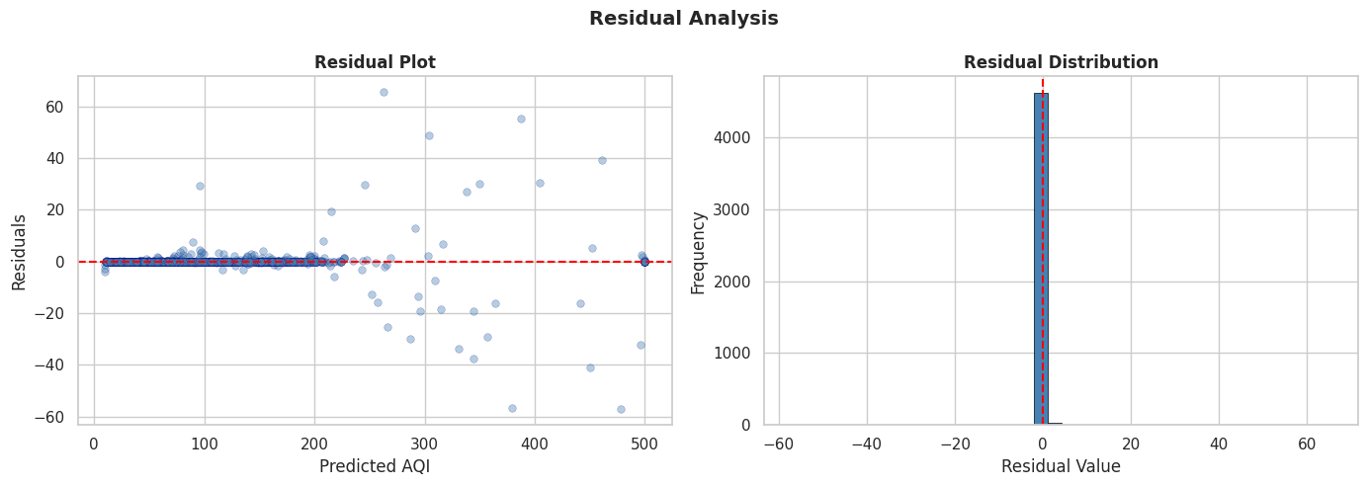
Figure 14 Residual Analysis
Residual analysis shows that prediction errors are centered around zero with no significant bias, although the spread of residuals increases slightly at higher AQI values. This indicates that while the model is generally accurate, predicting extreme pollution levels remains more challenging due to higher variability in those regions.
However, the exceptionally high R² score must be interpreted critically. AQI is not an independent variable but is mathematically derived from pollutant sub-indices, particularly PM2.5. As a result, the model is effectively learning a deterministic relationship rather than discovering new patterns. This limits its practical predictive value, as it does not provide additional insight beyond the underlying AQI calculation.
Therefore, while the model demonstrates strong performance, its real-world applicability would be significantly enhanced by extending the approach to predict future pollutant levels or incorporating time-series data. This would enable the system to function as a true forecasting tool rather than simply replicating existing relationships.

4. Insights
The analysis of the AQI dataset provides several important insights into global air quality patterns, pollutant behavior, and their implications for decision-making and policy development. These insights go beyond descriptive analysis and highlight actionable conclusions derived from the data.
One of the key insights is that global air quality is highly uneven, with the majority of cities falling within acceptable AQI ranges while a smaller proportion experiences extremely high pollution levels. This indicates that air pollution is not a uniformly distributed problem but is concentrated in specific regions. The implication is that global averages can be misleading, as they mask critical pollution hotspots. Therefore, targeted interventions in high-risk areas would be more effective than broad, generalized policies.
Another major insight is the dominant role of PM2.5 in determining overall AQI levels. The analysis consistently shows that PM2.5 has the strongest influence on AQI, both statistically and visually. This suggests that most air quality issues are primarily driven by fine particulate matter rather than a balanced contribution from multiple pollutants. The implication is that reducing PM2.5 emissions would have the most significant impact on improving air quality. Actions such as controlling vehicle emissions, regulating industrial output, and managing construction-related dust are therefore critical.
Country-level analysis reveals that high pollution levels are often associated with structural factors such as industrialization, urban congestion, and energy consumption patterns. Countries with consistently high AQI values reflect long-term environmental challenges rather than temporary fluctuations. This implies that effective solutions require systemic changes, including stricter environmental regulations, investment in renewable energy, and improved urban planning.
The analysis also highlights that different regions exhibit different pollution profiles. While some regions are dominated by particulate pollution, others show relatively higher levels of pollutants such as ozone. This suggests that air pollution is context-dependent, and a single universal solution is unlikely to be effective. Instead, region-specific strategies tailored to dominant pollution sources are required.
From a predictive perspective, the model demonstrates very high accuracy in estimating AQI values based on pollutant inputs. However, this insight must be interpreted critically. Since AQI is mathematically derived from pollutant sub-indices, the model is effectively replicating an existing relationship rather than discovering new predictive patterns. This implies that the true value of predictive analytics lies not in estimating AQI from current pollutants, but in forecasting future pollutant levels or detecting abnormal pollution spikes.
Finally, the presence of extreme AQI values indicates the occurrence of severe pollution events, which represent critical public health risks. These are not anomalies to be ignored but key signals that require immediate attention. This suggests the need for real-time monitoring systems and early warning mechanisms to mitigate the impact of such events.
Overall, the insights derived from this analysis emphasize that air pollution is driven by a combination of dominant pollutants, regional characteristics, and structural factors. Effective management of air quality therefore requires targeted, data-driven strategies rather than generalized approaches.

5. Deployment of the Proposed System
The developed AQI prediction process can be deployed as a web-based application to enable real-world usage and accessibility. The trained Random Forest model can be exported using serialization techniques such as joblib and integrated into a backend system developed using frameworks such as FastAPI or Flask. This backend will serve as the core of the system, providing an API endpoint where users can input pollutant values, including CO, Ozone, NO2, and PM2.5, and receive predicted AQI values in real time.
To improve usability and accessibility, a user-friendly frontend interface can be developed using tools such as Streamlit or other web technologies. This interface can function as an interactive dashboard, allowing users to visualize air quality patterns, explore pollutant trends, and input data for prediction. Such a system would be particularly useful for environmental monitoring agencies, researchers, and the general public, as it translates complex data into actionable insights.
For data management, the system can be extended to incorporate automated data ingestion pipelines. Instead of relying on static datasets, real-time air quality data can be collected through APIs such as OpenAQ. This data can be stored in databases such as PostgreSQL or MongoDB, enabling continuous updates and maintaining historical records for further analysis. This transition from batch processing to automated data pipelines significantly enhances the system’s practicality and relevance in real-world scenarios.
In terms of scalability, the system can be deployed on cloud platforms such as AWS, Google Cloud, or Render, ensuring that it can handle larger datasets and multiple user requests efficiently. Containerization using Docker can be implemented to package the application, including the model, backend, and dependencies, making deployment more consistent and easier to manage across different environments.
Furthermore, the system can be enhanced by integrating additional features such as alert mechanisms that notify users when AQI levels exceed critical thresholds, or by incorporating time-series forecasting models to predict future air quality trends. These improvements would extend the system from a simple prediction tool to a comprehensive air quality monitoring and decision-support platform.
Overall, this deployment strategy ensures that the developed analytical process is not limited to a static report but can be transformed into a scalable, interactive, and real-time system capable of supporting informed decision-making and environmental management.

6. Conclusion
This report presented a comprehensive big data analysis of global air quality using the AQI dataset, following a structured approach that included data acquisition, exploratory data analysis, model development, insight generation, and deployment planning. The analysis provided a detailed understanding of how air pollution varies across regions and how different pollutants contribute to overall air quality.
One of the most significant findings of this study is the dominant role of PM2.5 in determining AQI levels. Across all analyses, PM2.5 consistently showed the highest variability, strongest correlation with AQI, and the greatest influence in the predictive model. This indicates that air quality degradation is primarily driven by fine particulate matter, making it the most critical factor to address in pollution control strategies.
The study also highlighted that air pollution is not uniformly distributed but is concentrated in specific regions influenced by factors such as industrialization, urbanization, energy consumption, and environmental conditions. This implies that effective air quality management requires targeted, region-specific interventions rather than generalized global approaches.
Although the Random Forest model achieved very high predictive accuracy, this performance must be interpreted critically, as AQI is mathematically derived from pollutant sub-indices. As a result, the model primarily captures an existing deterministic relationship rather than uncovering new patterns. This suggests that future work should focus on forecasting pollutant levels and incorporating time-series data to enhance predictive capabilities.
Overall, the project demonstrates how data-driven approaches can be used to analyze environmental challenges and generate meaningful insights. By combining analytical techniques with scalable deployment strategies, the proposed system has the potential to support real-time air quality monitoring and informed decision-making, contributing to improved public health and environmental sustainability.

GitHub Repo Link : https://github.com/grishmalamsal/Big_Data_Workshop/blob/main/Workshop_2.ipynb

